Spark on HDInsight

(1) Set up a Spark cluster with the respective resource group and login credentials.
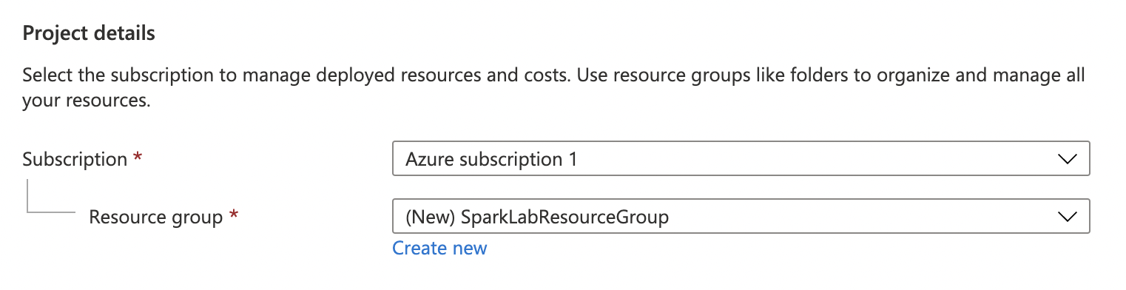

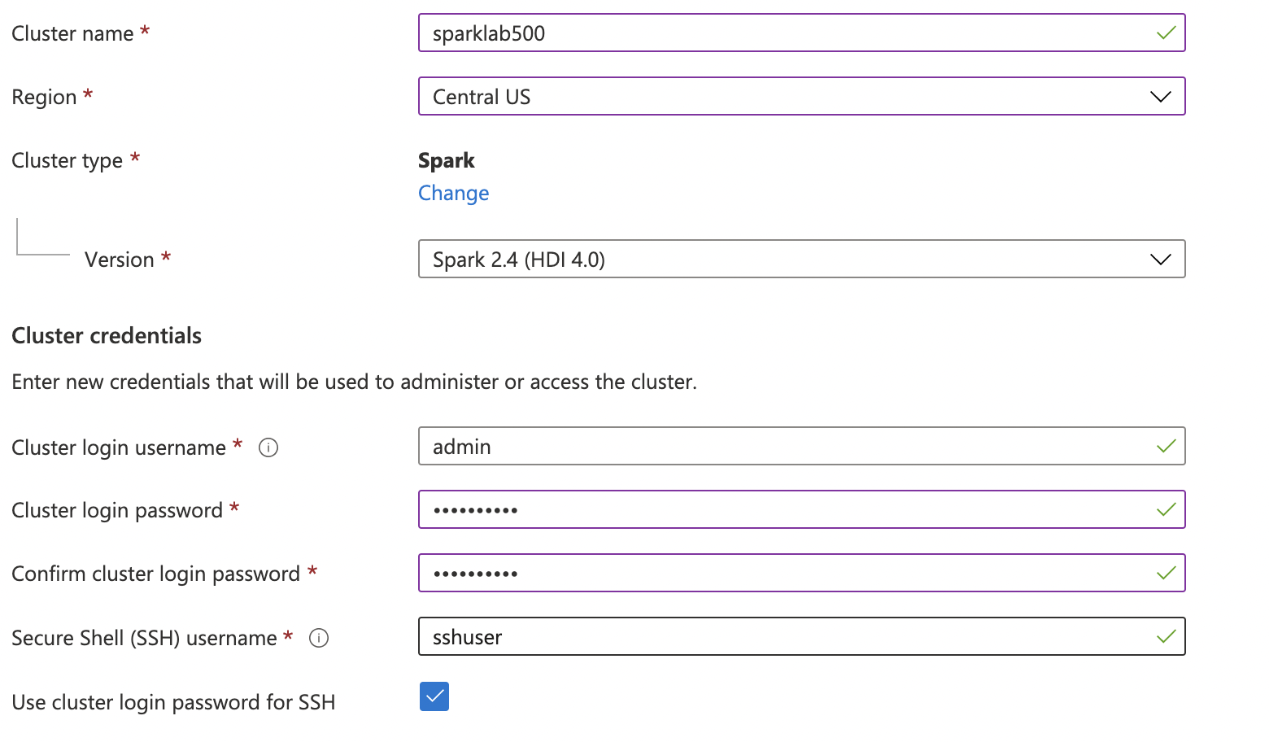

(2) Identify Azure storage as the primary storage.
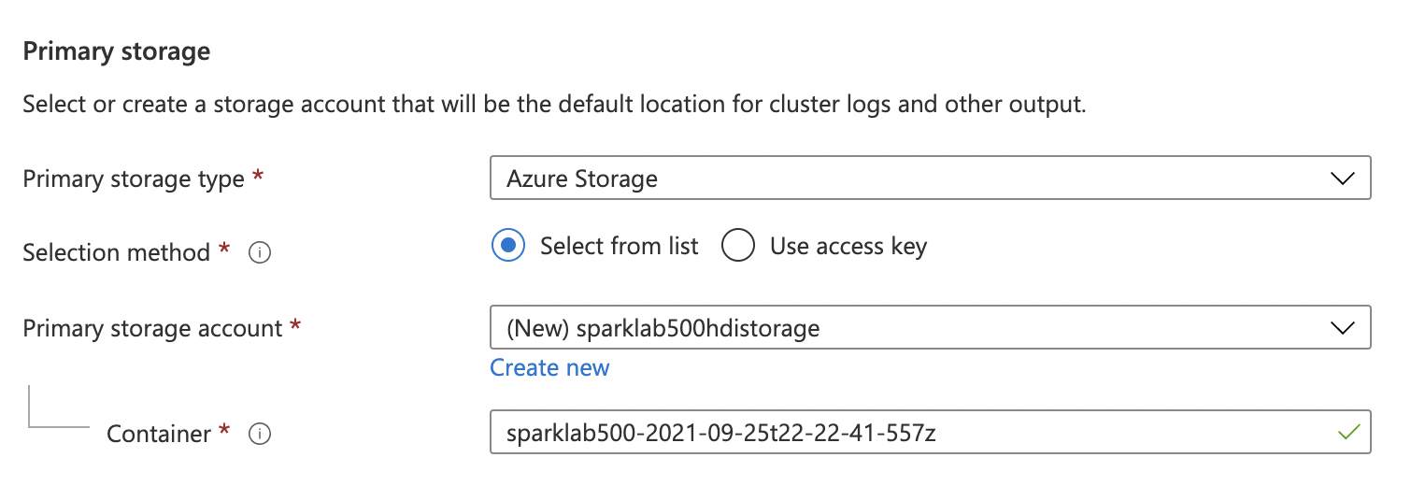

(3) Set up the head and worker node

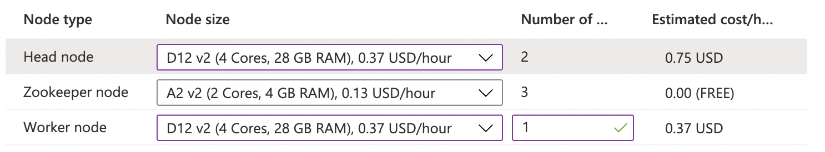

(3) Create the spark cluster and allow time for deployment.
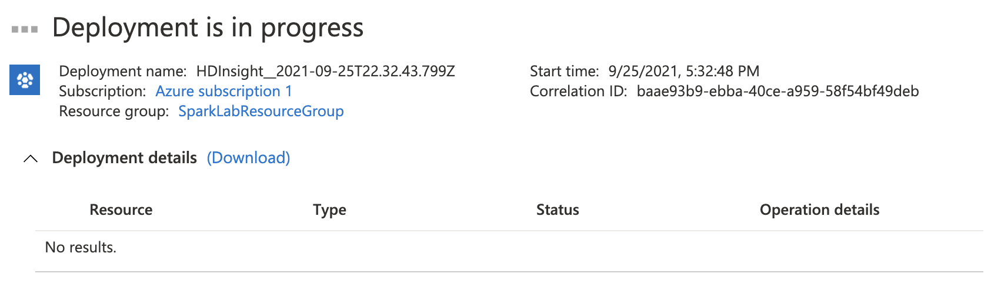

(4) Use Azure Storage Explorer to upload the .ipynb file and the .csv file.

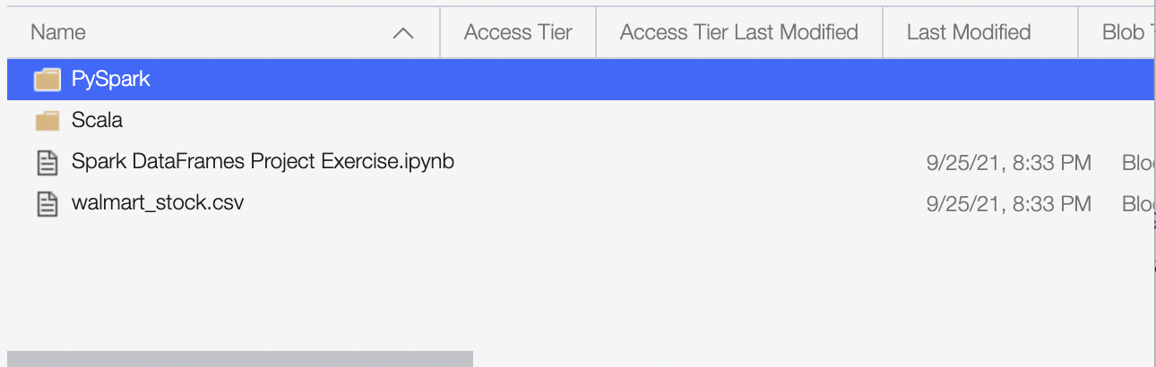

(5) Locate the resource group pertaining to the Spark cluster.
